AI Systems Architecture and Engineering - Homework Assignment 2 – Submission Report
OpenAI Agents SDK Multi-Agent System

1. System Architecture Overview
The implemented system is a modular multi-agent architecture built using the OpenAI Agents SDK. Its primary goal is to improve decision-making, safety, and modularity by separating responsibilities across specialized agents and enforcing structured communication between components.
Core Design Philosophy
The system follows a router-based multi-agent pipeline:
User Input → Input Guardrails → Router Agent → Task Agents (via Handoffs) → Tools → Output Guardrails → Response → Memory Persistence
This design ensures:
- Separation of concerns between agents
- Deterministic tool execution
- Safe and validated input/output flow
- Persistent conversation memory

2. Agents and Their Roles
Router Agent
The Router Agent is responsible for:
- Classifying user intent using few-shot prompting
- Selecting the appropriate downstream agent
- Passing structured input to the execution layer
Supported intents:
- getWeather
- calculateMath
- getExchangeRate
- generalChat
It outputs structured JSON including:
- intent
- parameters
- confidence score

Task Agents
Weather Agent
- Handles weather-related queries
- Uses get_weather tool (external API integration)
Math Agent
- Handles arithmetic and word problems
- Converts natural language into mathematical expressions
- Uses deterministic calculate_math tool
Exchange Rate Agent
- Handles currency conversion queries
- Uses static or API-based exchange rate tool
Chat Agent
- Handles general conversation
- Implements a defined persona:
  - “Cynical but helpful research assistant”
  - Short responses with data engineering metaphors
  - Enforces refusal for unsafe or restricted content

3. Tools Implementation
The system uses deterministic tools to ensure correctness and reproducibility:
- getWeather: Fetches real-time weather data via external API
- calculateMath: Evaluates mathematical expressions safely
- getExchangeRate: Returns currency conversion rates
Tools are executed only after agent-level interpretation, ensuring the LLM does not perform direct computation.

4. Handoffs Mechanism
The system uses SDK-native handoffs instead of manual routing logic.
Flow example:
- Router Agent detects weather intent
- Handoff is triggered to Weather Agent
- Weather Agent calls the weather tool
- Output is processed and returned
At least two real handoffs are demonstrated in the system:
- Router → Weather Agent
- Router → Math Agent (word problem decomposition)
This ensures a fully modular execution pipeline without hardcoded conditional logic.

5. Guardrails System (Security Layer)
The system implements a hybrid guardrails architecture combining rule-based logic and LLM-based classification.
Input Guardrails
- Empty input detection
- Prompt injection detection
- Malicious intent filtering (LLM-based classification)
- Unsupported content filtering (political / irrelevant queries)
Output Guardrails
- Schema validation of structured outputs
- Safety filtering using LLM evaluation
- Length and format validation
- Blocking of unsafe or non-compliant responses
Example Blocked Cases
- Prompt injection attempts (“ignore previous instructions”)
- Political questions (“who should I vote for”)
- Malicious requests (“write hacking script”)
All violations are logged and blocked before reaching execution or user output.

6. Memory Management System
The system implements persistent memory using a local file:
history.json
Requirements Fulfilled
1. Load on Startup
- If history exists → load conversation
- System prints: “Welcome back”
- If not → initialize empty memory
2. Context Injection
- Entire conversation history is converted into messages[]
- Injected into every LLM call for contextual awareness
3. Save After Interaction
- Memory is updated after every full user-agent exchange
- Also saved automatically on program exit using atexit
4. Reset Functionality
- /reset command deletes history.json
- Clears in-memory state
- Starts fresh session

7. Logging and Observability System
A structured logging system was implemented to ensure full traceability of system behavior. Logs are stored per session in JSON format.
Logged Events
- INPUT_RECEIVED
- INPUT_BLOCKED
- ROUTER_OUTPUT
- CONTEXT_INJECTED
- TOOL_CALL
- HANDOFF
- FINAL_RESPONSE
- OUTPUT_BLOCKED
- MEMORY_SAVED
- MEMORY_RESET
Purpose of Logging
The logging system enables:
- Full reproducibility of system behavior
- Debugging of agent decisions
- Proof of guardrail enforcement
- Visualization of handoffs and tool usage
Each execution generates a structured log file used for evaluation screenshots.

8. Demonstration Coverage (Demo Script Execution)
A deterministic demo script was executed to validate all system requirements.
Covered Scenarios
- Correct routing of weather query (handoff)
- Word problem decomposition into math expression
- Currency conversion via tool execution
- General chat response using persona
- Input guardrail blocking malicious prompt injection
- Output guardrail blocking unsafe response
- Memory reset and persistence validation
- Context injection verification across turns

9. Conclusion
This system demonstrates a full production-style multi-agent architecture using the OpenAI Agents SDK. It successfully integrates:
- Modular agents with clear responsibilities
- Structured routing with few-shot prompting
- SDK-native handoffs instead of manual logic
- Deterministic tool execution
- Multi-layer hybrid guardrails (rule + LLM)
- Persistent memory with context injection
- Full observability through structured logging
The result is a secure, extensible, and maintainable multi-agent system that satisfies all assignment requirements while reflecting real-world production design principles.

System Architecture
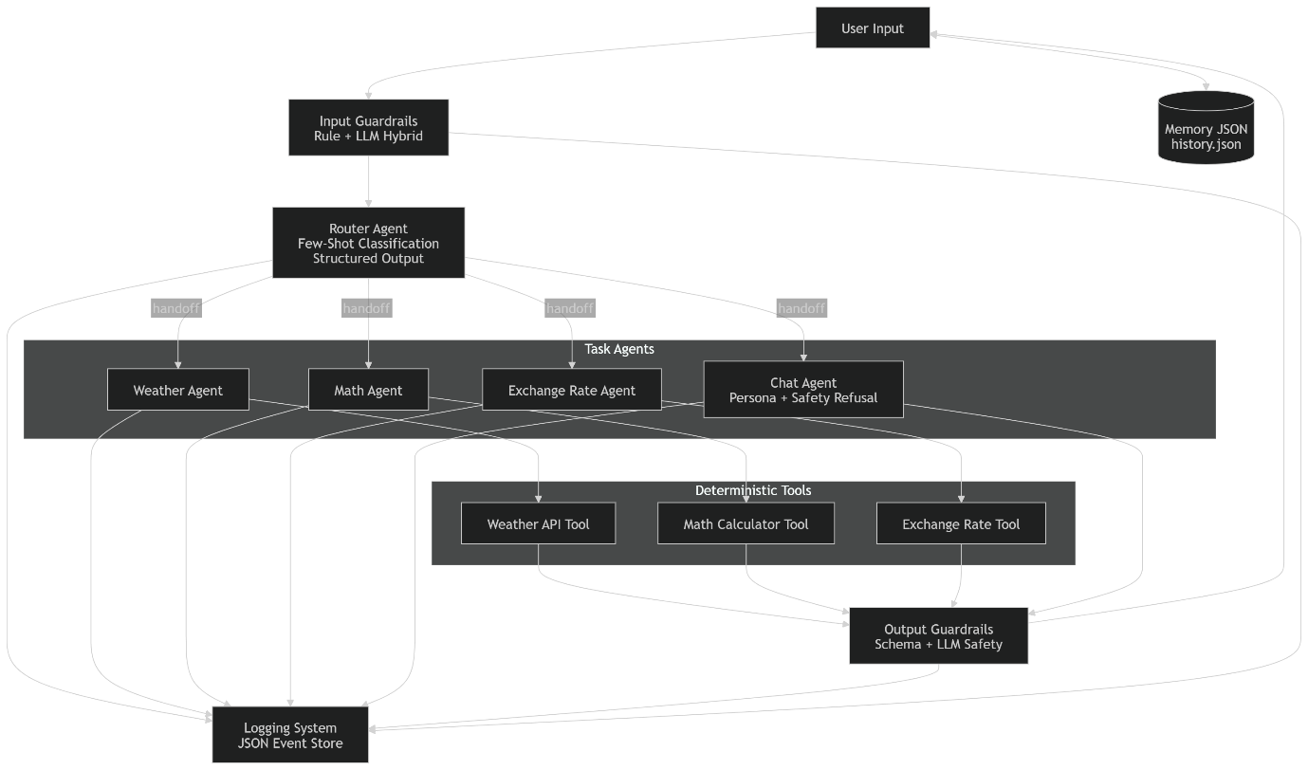
This diagram illustrates a modular multi-agent system built using the OpenAI Agents SDK.
Flow Overview:
- User input enters the system.
- Input Guardrails validate safety and correctness using rule-based and LLM-based checks.
- The Router Agent performs few-shot classification and returns a structured intent.
- Based on the intent, a handoff is performed to the appropriate task agent.
- Task agents call deterministic tools when required.
- Output Guardrails validate safety, structure, and compliance of the final response.
- Memory is persistently stored in a JSON file and injected into LLM context.
- A logging system records every step for full traceability and debugging.

